Checkpoint 1- Life Below Water

Design ideas:

Color Scheme
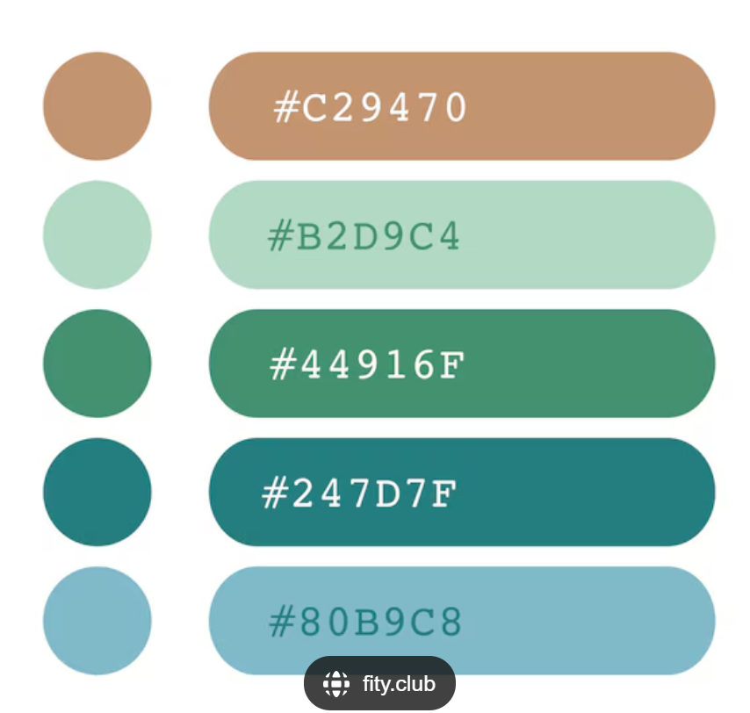
#80B9C8 (background color)
#247D7F (font color)

Google fonts
Title - Stack Sans Notch
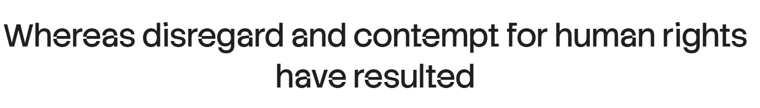
Body (content) - Roboto Flex
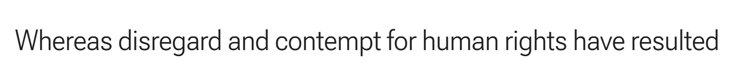
Extra font - Barlow
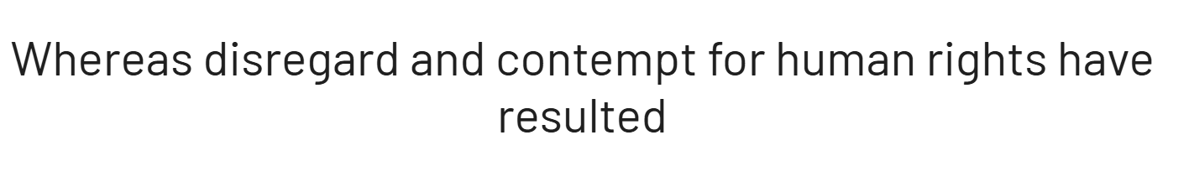

Sitemap of website:
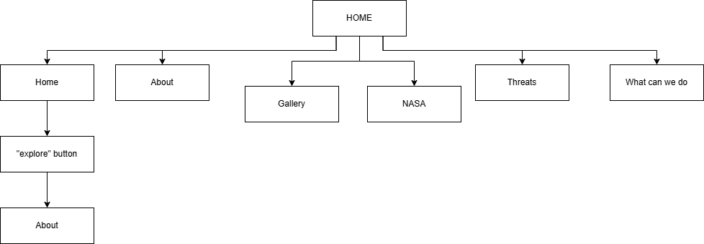

Wireframes:
HomePage;
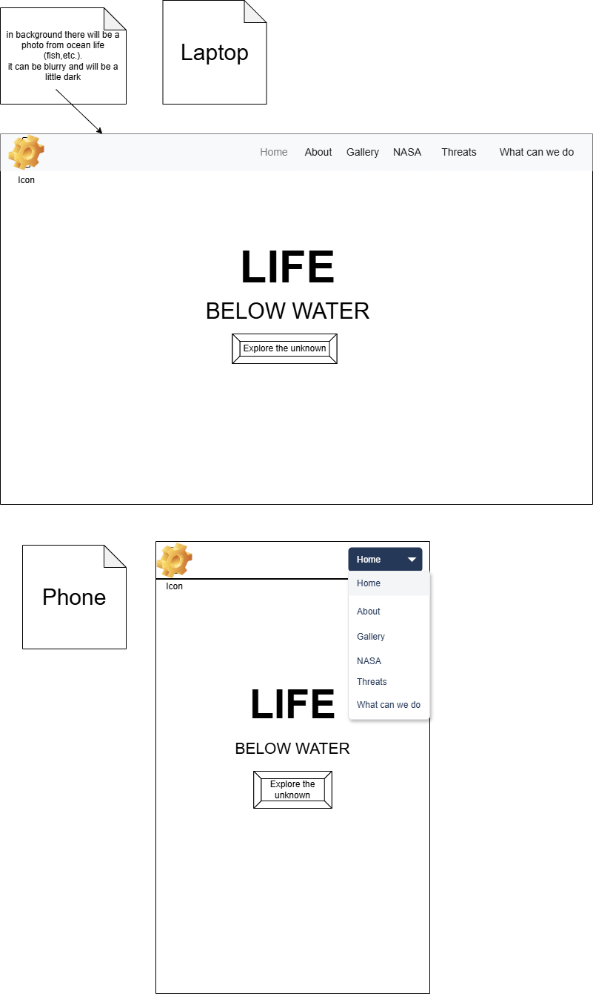
AboutPage;
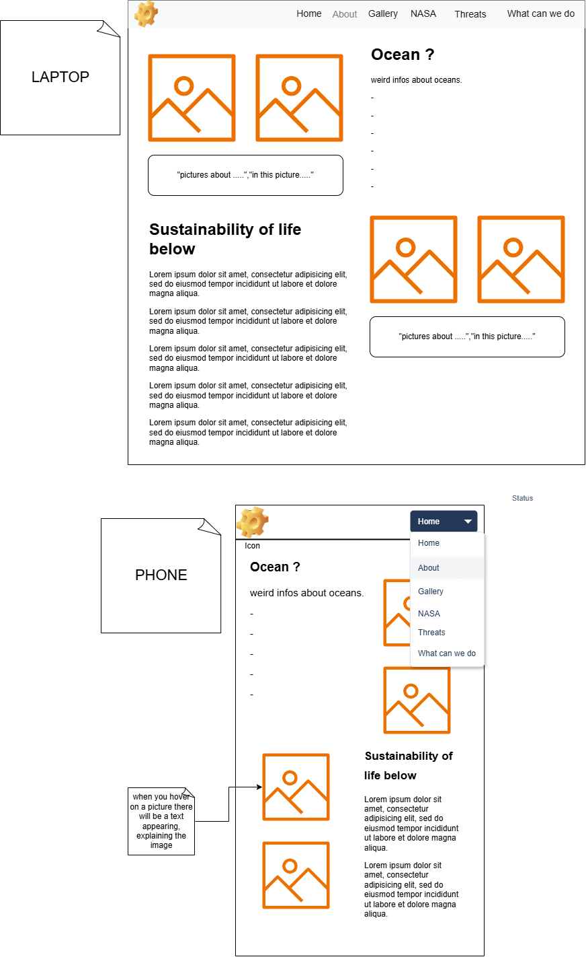

ThreatsPage;
Desktop Version | Mobile Version
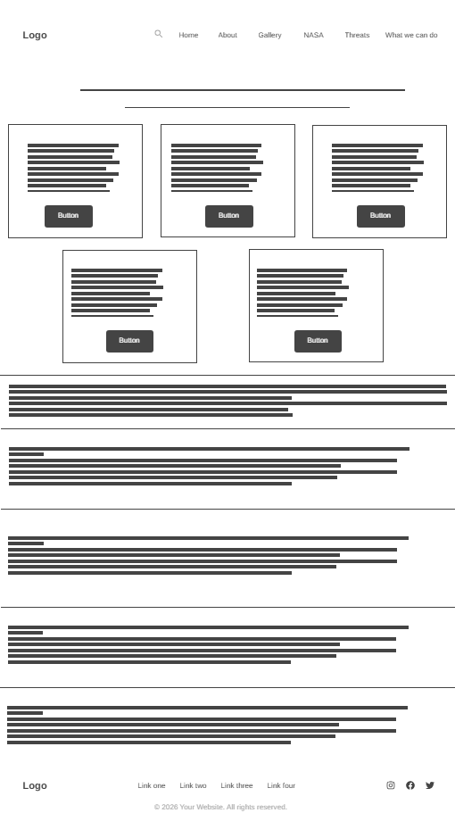 | 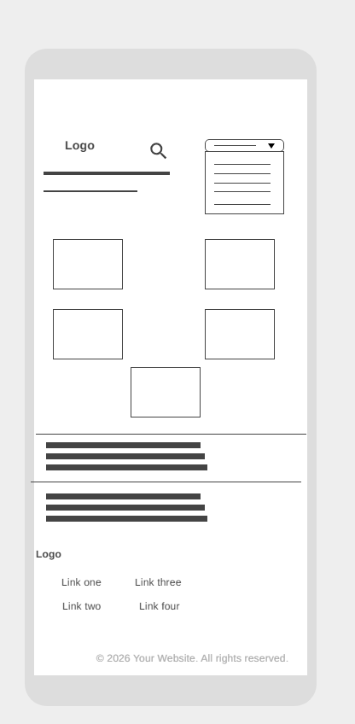

What_can_we_doPage;
Desktop version | Mobile version
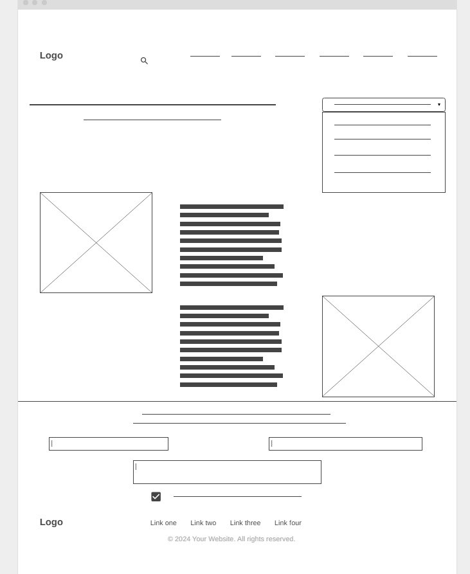

Gallery Page

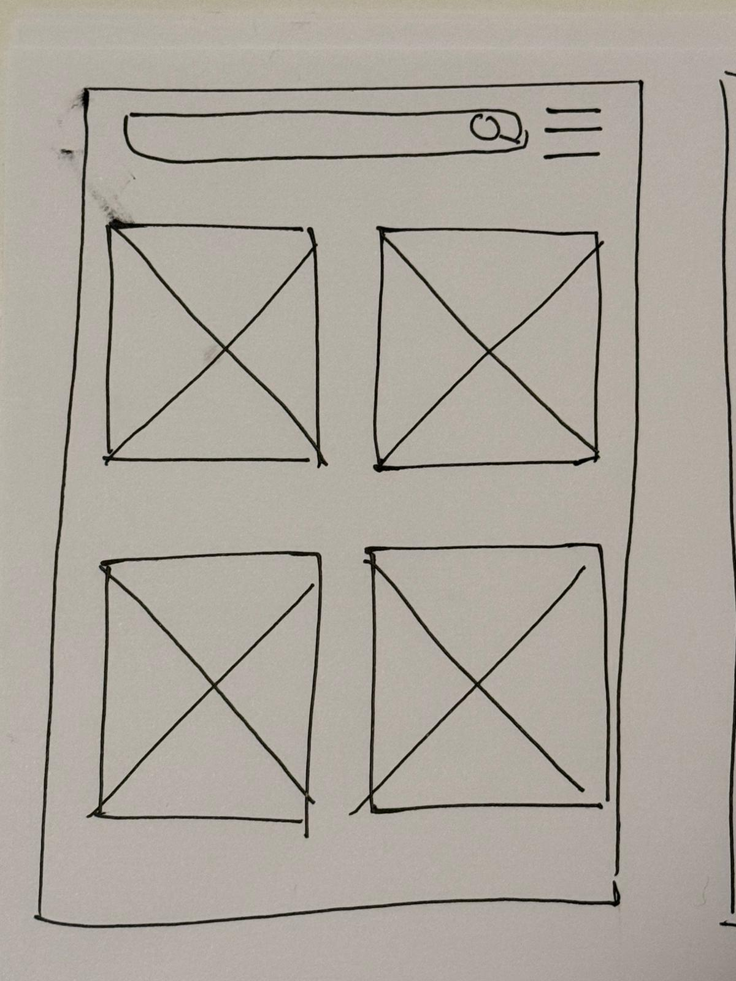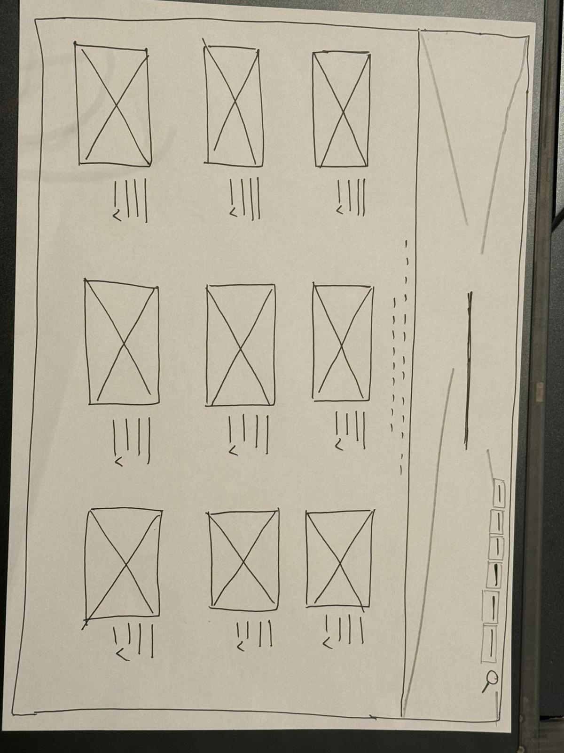
(Mobile view) (Desktop view)

NASA Page
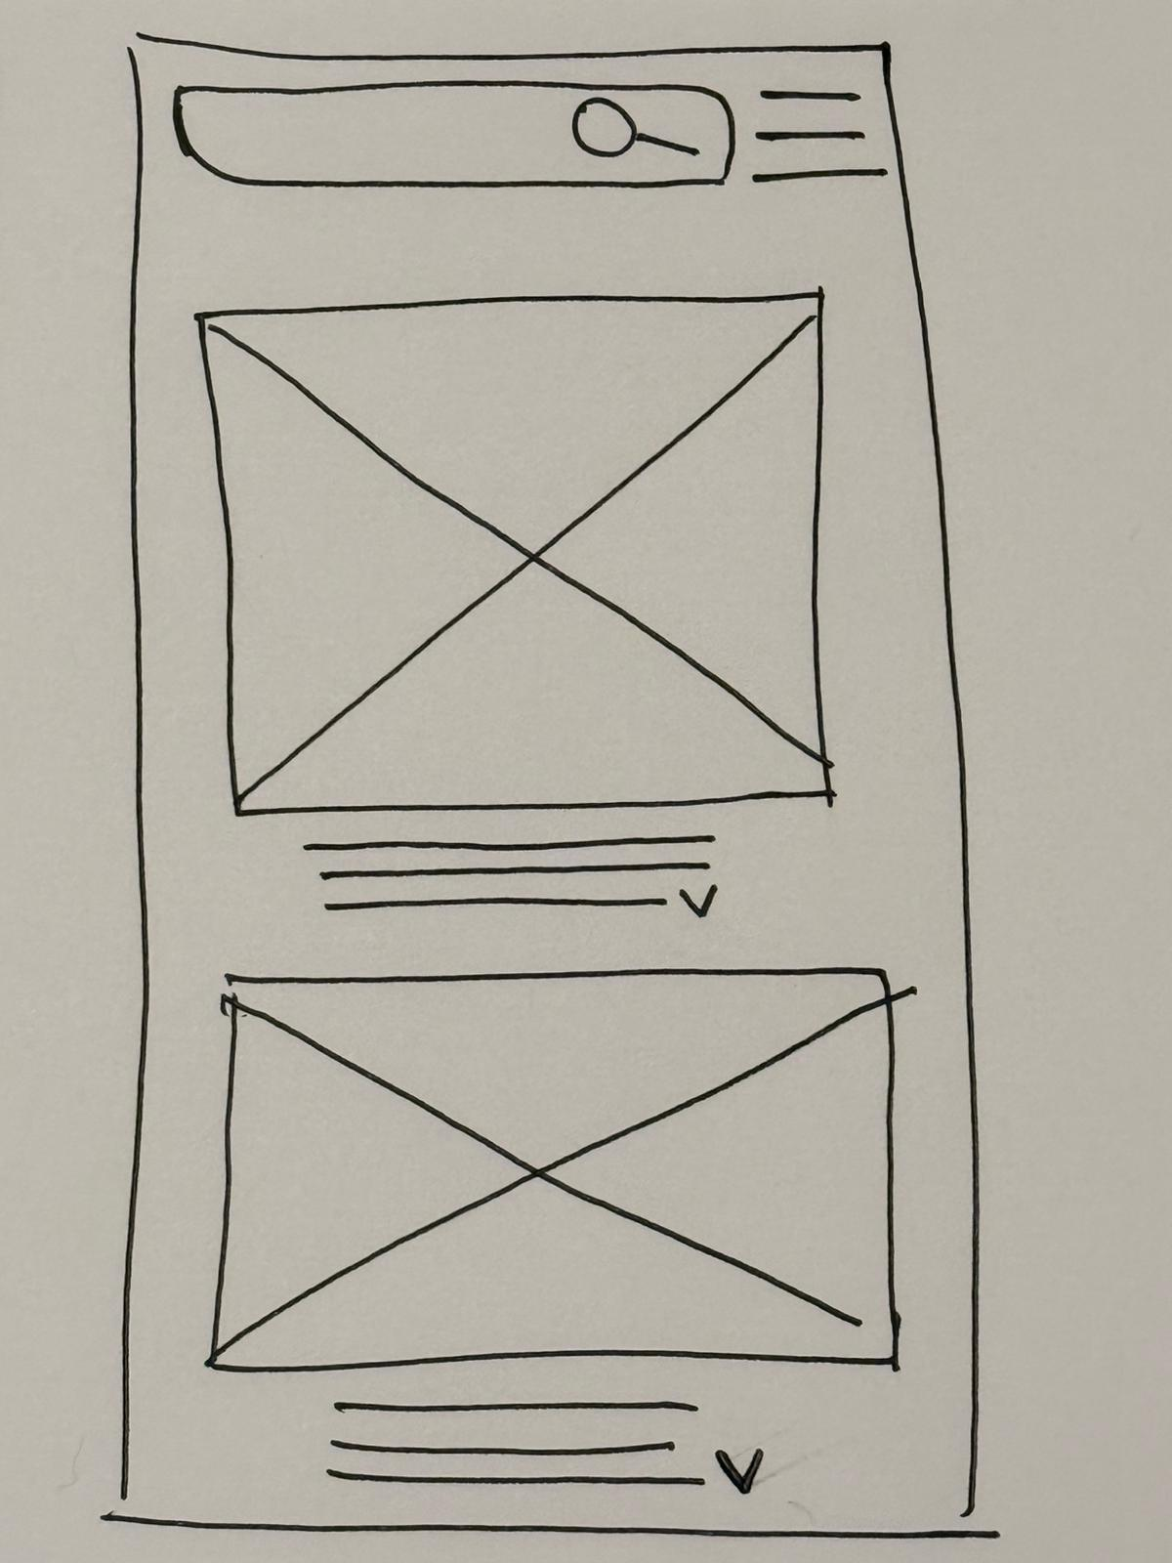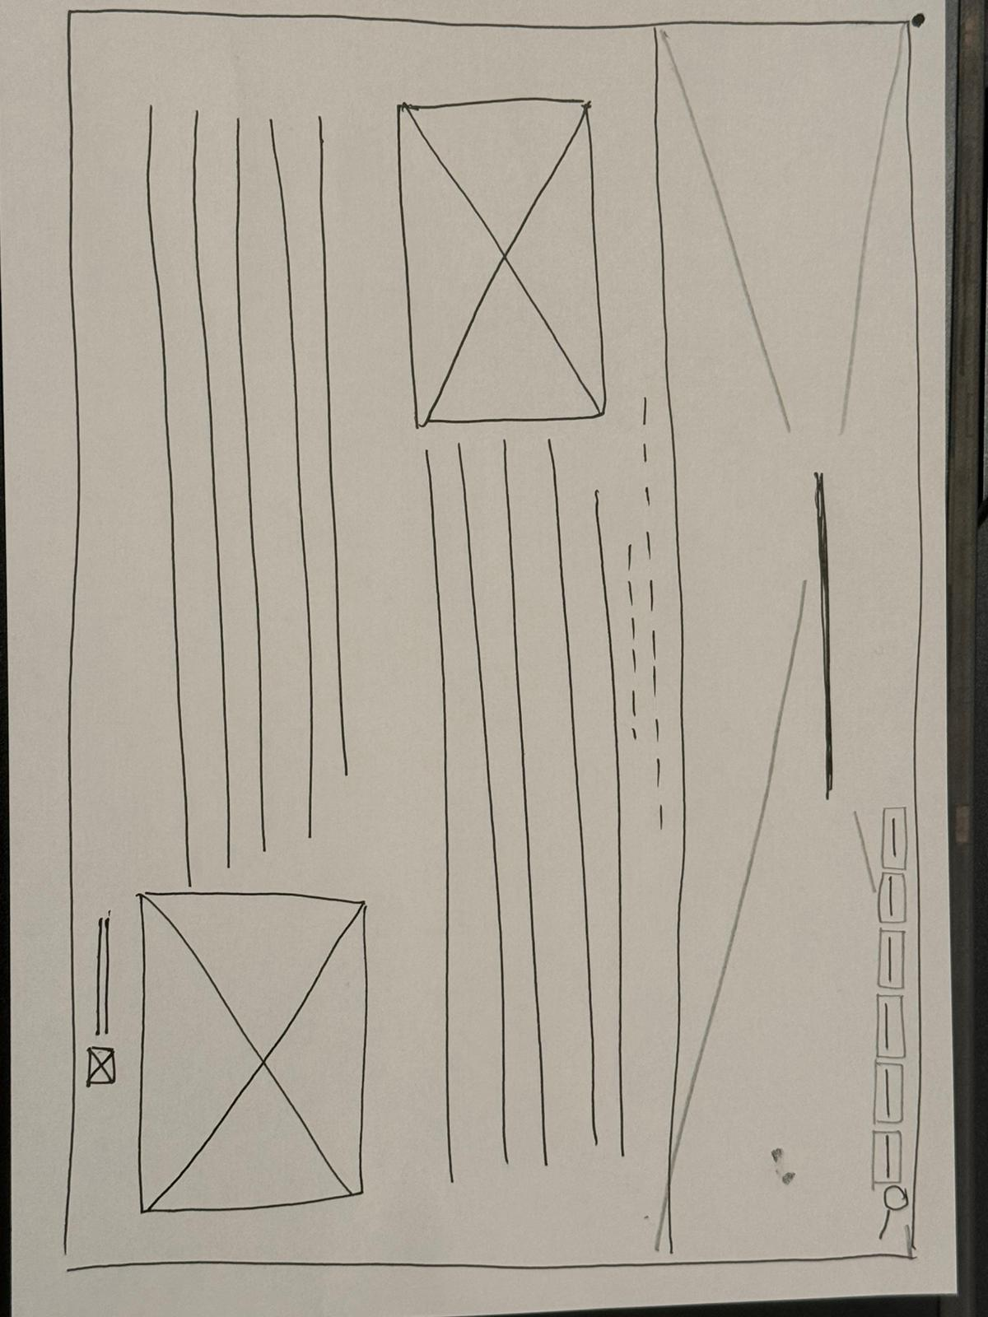
(Mobile view) (Desktop view)

Excel sheet of tasks broken down:
…

GitHub link to repos:
Eda= https://github.com/handeedaoz/WDD_GroupQ.git
Menomi - https://github.com/Meno20/Group-Q--Web-design-MenomiGamage-.git
Htet Oo Khin - https://github.com/htetookhin/WDD-Project.git

